Math 1 Name_______________________________

**5-2 – 5-4 Review** Date________

* *I can find the equation of a line parallel to another line through a given coordinate.*
* *I can find the equation of a line perpendicular to another line through a given coordinate.*
* *I can find the distance between two points.*
* *I can find the midpoint of a line segment.*
* *I can determine the area and perimeter of shapes from coordinates.*

**State whether the graphs of the following equations are parallel, perpendicular, or neither.**

1. 



2. 



3. 



4. 



**Find the value of *a* for which the graph of the first equation is perpendicular to the graph of the second equation.**

5. 

6. 

**Find the midpoint of the line segments with the given endpoints.**

7. (–5, 8) & (3, 10)

8. (–23, –14) & (42, –9)

**Use the information given to find the missing endpoint of the following line segments.**

9. Given one endpoint is (7, –2) and the midpoint is (2, 4):

10. Given one endpoint is (–15, –4) and the midpoint is (2.5, –8):

**Use the information given to find the value of *z*.**

11. The distance between (–12, 9) and (–5, *z*) is 

12. The distance between (*z*, 22) and (–11, –50) is 78.

**Find the area and perimeter of the figures below. Unless told otherwise, assume the *x* and *y-*axis have a scale of one on all given graphs.**

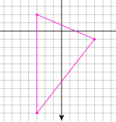13.

14. A triangle with vertices (–3, 10), (–3, 8), and (1, 10):

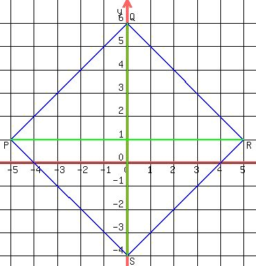15.

16. Rectangle *ABCD* with vertices *A*(0, 5), *B*(9, 5), *C*(9, –1), and *D*(0, –1).

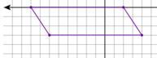17.

18. Parallelogram *WHAT* with vertices *W*(0, 2), *H*(1, 2), *A*(8, –1), and *T*(7, –1).

19. Rhombus *NIDY* with vertices *N*(0, –3), *I*(3, 1), *D*(8, 1), *Y*(5, –3).

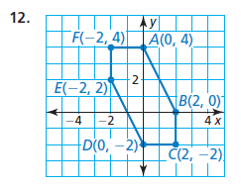20. Find the area of the figure below. You do not need to calculate the perimeter.

21. Find the equation of the line through (4, 2) parallel to *y* = *x* + 4 in both point-slope and slope-intercept form.

22. Find the equation of the line through (4, 2) perpendicular to *y* = *x* + 4 in both point-slope and slope-intercept form.

23. Find the equation of the line through (1, -5) parallel to ** in both point-slope and slope-intercept form.

24.Find the equation of the line through (1, -5) perpendicular to ** in both point-slope and slope-intercept form.